S1 Table. **R scripts.** All files and model output are available for upload from the github.com/bchasco/sar_paper.

|  |  |  |
| --- | --- | --- |
| File | Description | Output |
| create_DataAndPars.r | Creates a list of data and parameter objects that are used by the TMB obj | data (list)  parameters (list) |
| create_MapAndObj.r | Creates a map list of parameters and random effects that are not to be estimated by the TMB object, Obj. | myMap (list)  Obj (TMB) |
| wrapper_modelRuns.r | A wrapper that takes user defined inputs and then run the optimization for the TMB object. | rep (list) – TMB output  SD (list) – TMB output |
| wrapper_simRuns.r | A wrapper to do the simulation testing for the parameters of the best fit model to the wild spring/summer Chinook salmon | simMelt (data.frame) – estimated parameters for the simulated data sets |
| wrapper_simQuadratic.r | A wrapper to compare the parameters estimates for the simulated data based on our AR1 model for day and day/year interaction model with a mixed-effect model where day effect is a fixed effect described linear combination of day and day2 | simMelt (data.frame) – estimated parameters for the simulated data sets |
| fig_AnnualSurv_ggplot.r | Plot of annual survival | fig_AnnualSurv_ggplot.tiff |
| fig_DailySurv_ggplot.r | Plot of daily survival, aggregated across years | fig_DailySurv_ggplot.tiff |
| fig_DayXYearSurvival_ggplot.r | Plot of daily survival by year | fig_DayXYearSurvival_ggplot.tiff |
| fig_envEffect_ggplot.r | Plot of the environmental effects | fig_envEffect_ggplot.tiff |
| fig_EnvironmentalVariableWt_ggplot.r | Plot of the predictive ability of the different environmental covariates | fig_EnvironmentalVariableWt_ggplot.tiff |
| table_AIC.r | Table of the AIC values for the top models | table_AICOutput.csv |
| table_bestFitMods.r | Table of best-fit models for hatchery and wild fish | table_bestFitMods.csv |
| table_resDeviance.r | Table of residual deviances for different fixed and mixed-effect models | table_resDeviance.csv |

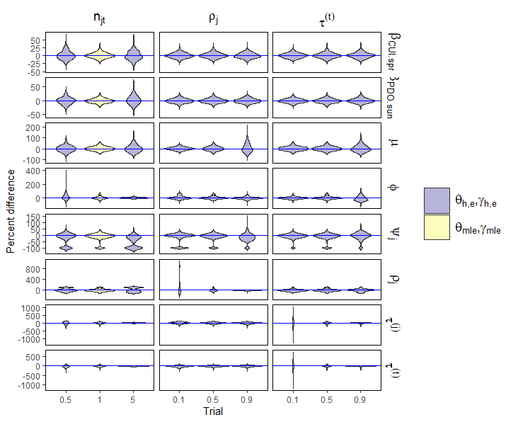

S1 Fig. **Estimates of parameter bias.** Violin plot of the percent difference between the estimated and “true” parameter values (rows) for three experiments (columns) related to sample size $\left(n_{jt}\right)$, correlation of the daily random effects $\left(ρ_{j}\right)$, and correlation of the day/year random effects $\left(τ^{\left(j\right)} and τ^{\left(t\right)}\right)$. The simulated data for the wild spring/summer Chinook salmon is based on the vectors of maximum likelihood parameters estimates ( $θ_{mle}$ and $γ_{mle}$, yellow violins), or the manipulation the sample size or some element of those vectors based on different trials (h; x-axis) and experiment (e; columns). For compactness, we removed the r subscript and superscript for the parameters since all simulations are for wild fish. To recreate the results of these simulation experiments refer to the Appendix Table.A2.

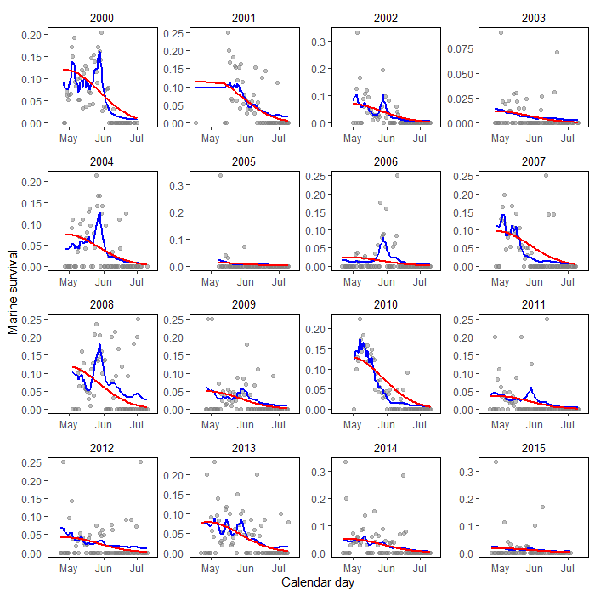

S2 Fig. **Simulated data and model fit for a simulation realization.** A single realization of the simulated smolt-to-adult (SAR; grey points) for wild spring/summr Chinook salmon based on the mle estimates for the simulation model with AR1 processes for the day and day/year interactions. The blue lines represent the SAR estimates for TMB estimation model with AR1 process for day and day/year, and the red lines represent the glm model implemented in R with fixed-effects for day, day2, and the day/year interaction.